Pruning for energy supply chain in Apulia Region – FIUSIS power plant
Calimera (Lecce, Apulia, Italy), Friday 5th April 2019
AGROinLOG would like to invite you to an open demo day of an existing value chain based on the energetic utilization of olive tree prunings in Apulia, Italy.

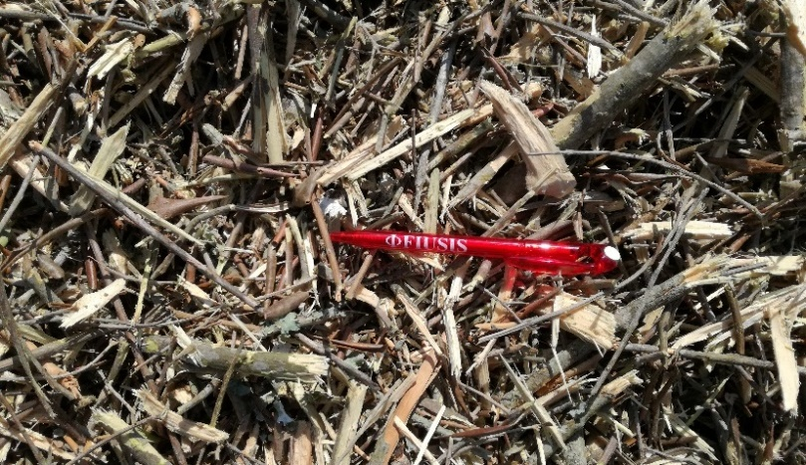
Figure 1 – Hog fuel from olive tree prunings.

Olive tree prunings are an abundant residual agrobiomass in southern Europe, in areas where olive trees are cultivated. Depending on the olive tree variety, local agronomic practices and other factors, prunings are produced annually or biannually as part of the agronomic operations for the maintenance and well-being of the olive trees. It is common practice that farmers dispose of these prunings in open field fires, without any form of valorisation and causing seasonal air emissions.
Harvesting olive tree prunings for energy value chains is a very interesting alternative for the management of this residue. Several manufacturers have developed different technologies for harvesting prunings from the fields [1] and there are examples of real value chains based on this material in Spain and Italy [2].
This particular AGROinLOG demo day will revolve around the case of FIUSIS, which is the world’s first biomass power plant (1 MWe) fuelled exclusively by olive tree prunings. The plant mobilizes around 8,000 tons of olive tree prunings annually sourced from a radius of 15 km [2].
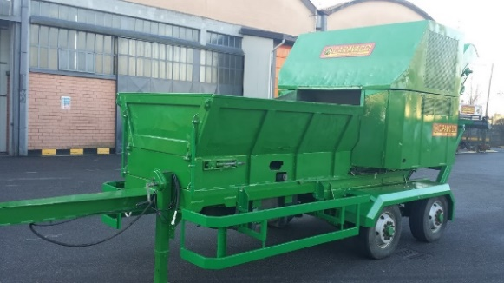
Figure 2 – The harvesting implements used by Fiusis.

In the course of the demo day, participants will have the chance to visit the Fiusis power plant and see the equipment used for power production; additionally, a Q&A session with the plant manager will be organized in order to develop an understanding of how this successful case of olive tree pruning utilization materialized.
Additionally, the participants will have the chance to see an on-field demonstration of two different harvesting methods used by the logistics operators of Fiusis to collect olive tree prunings:
- Integrated harvesting and shredding of olive tree prunings using the Comby TR200 harvester produced by FACMA (Figure 2 – left).
- Forwarding of olive tree prunings to the side of the field and treatment with a stationary chipper Caravaggi (Figure 2 – right).
The demo-day has been organized by CREA in collaboration with CERTH and INASO-PASEGES and with the support of Fiusis power plant, Becool [3] and the uP_running [4] projects.
AGROinLOG project information
The main goal of AGROinLOG is the demonstration of Integrated Biomass Logistics Centres (IBLC) for food and non-food products, evaluating their technical, environmental and economic feasibility. An IBLC is defined as a business strategy for agro-industries to take advantage of unexploited synergies in terms of facilities, equipment and staff capacities, to diversify regular activity both on the input (organic raw materials) and output side (food, feed, biocommodities & intermediate biobased feedstocks) thereby enhancing the strength of agro-industries and increasing the added value delivered by those companies.
As part of AGROinLOG project, demonstrations of innovative harvesting machinery will be performed in order to make stakeholders know about it, discuss about the feasibility and understand potential uses of the products.

References:
- Pari, L., Suardi, A., García-Galindo, D., Bergonzoli, S., Alfano, V., Scarfone, A. (2018) Best Available Technologies for Pruning Harvesting. Proceedings of the 26th European Biomass Conference and Exhibition, pp. 55 – 63.
- CERTH (2017). uP_running Deliverable 6.3 Flagship success cases update v1. Available online at: http://www.up-running.eu/wp-content/uploads/2017/10/uP_running_D6.3-Flagship-cases-report-v1_.pdf
- Becool project website: https://www.becoolproject.eu/. This project has received funding from the European Union’s Horizon 2020 research and innovation programme under grant agreement No 744821.
- uP_running project website: http://www.up-running.eu/. This project has received funding from the European Union’s Horizon 2020 research and innovation programme under grant agreement No 691748.

Agenda of the Meeting
 | SUBJECT |  |  | Project AGROinLOG “Demonstration of innovative integrated biomass logistics centres for the Agro-industry sector in Europe”- GA no. 727961
 | MEETING |  |  | Pruning for energy supply chain in Apulia Region:  Site visit at FIUSIS pruning biomass based power plant and pruning harvesting demonstration with towed chipper Facma mod. Comby and stationary chipper caravaggi in Calimera’s olive groves (Lecce, Italy)
 | DATE |  |  | 5th April 2019
 | VENUE |  |  | Calimera (Lecce), Apulia Region, Italy
 | STARTING TIME |  |  | April 5th at 09:30 h
 | FINISHING TIME |  |  | April 5th at 15:00 h
Item |  | Time | Subject |  | Speaker
- |  | 08:15 | Bus Departure from Hotel Executive Inn (Brindisi) |  | -
- |  | 09:30 | Welcome at FIUSIS power plant |  | -
1 |  | 09:40 | The European Project AGROinLOG and pruning for energy demonstrations in Greece |  | Manolis Karampinis (CERTH)
2 |  | 10:00 | Technical means for harvesting prunings |  | Alessandro Suardi (CREA)
- |  | 10:20 | Coffee break |  | -
3 |  | 10:35 | FIUSIS: a success story |  | Marcello Piccinni (FIUSIS)
4 |  | 10:50 | Tour of FIUSIS power plant |  | Marcello Piccinni (FIUSIS)
5 |  | 11:20 | Discussion on FIUSIS experiences and prospects of olive tree pruning valorization in Italy and Greece |  | Marcello Piccinni (FIUSIS) & Manolis Karampinis (CERTH)
- |  | 12.00 | Lunch break |  | -
6 |  | 13:00 | Visit at local olive groves and pruning harvesting demonstration with Facma mod. Comby and stationary chipper Caravaggi |  | Marcello Piccinni (FIUSIS) & Alessandro Suardi (CREA)
- |  | 14:00 | Conclusion of field visit |  | -

