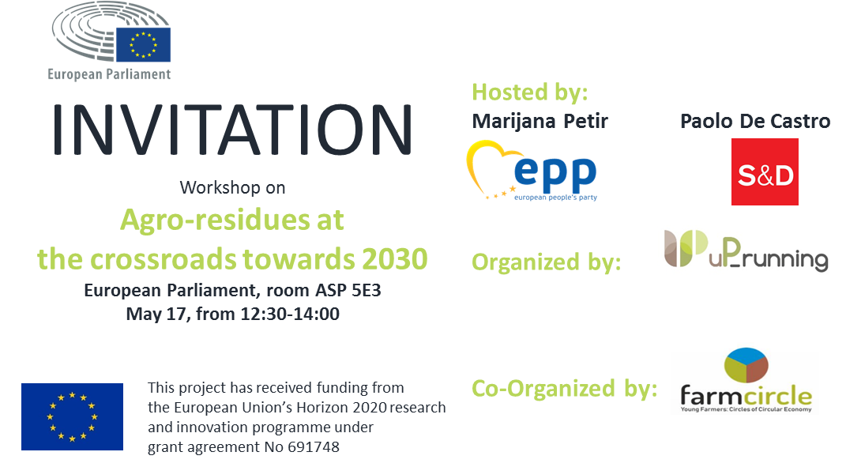
INTRODUCTION
Biomass contributes currently 60% of the total Renewable Energy share in Europe, and projections towards 2030 (assuming current target 27% RE in final energy consumption) foresee bioenergy could participate with 50% in this share, meaning a growth of 23 Mtoe of final energy. Covering this target will require a new mobilization of more than 80 Mt (dry matter) of biomass. European parliament requested December 2017 an increase in the weight of Renewable targets, and considers agricultural residues to be principally utilized for energy. The potential of agro-residues is high (different sources point from 20 to 60 Mtoe sustainably available) and sufficient to significantly contribute to the target on bioenergy. Nevertheless, the relevant domestic potential of agro-residues, they are not being utilized for energy purposes because of several constraints, logistical, social and related to regulatory and policy frameworks.
Residues from agricultural pruning and plantation removals (APPR) produced from vineyards, fruit and olive exploitations are a paradigm of the situation for agro-residues in Europe. This resource, estimated to be more than 25 Mt of biomass (dry matter) is almost unused (less than 10% estimated), and are not introduced in the European market.
Aim is to explain framework, realistic cases, keys for success, influencing regulations and framework conditions, real opportunities, and needs, all of them gathered through the consultation with stakeholders, policy makers and sectorial platforms in 7 EU countries, synthesized for this workshop in form of recommendations relevant for favoring a larger use of these resources.
With this workshop we would like to present the European strong potential of agro-residues through the case example of APPR residues and to evidence how its use is connected and an opportunity to rural development, bio economy and circular economy, and can be utilised respecting air quality and sustainability, whilst contributing to the development and growth in agricultural and energy sectors.

OBJECTIVES
To increase awareness of EU policy decision-makers by sharing the visions captured from agrarian, energy sector and rural communities on the current status, needs and opportunities to take advantage of in relation to agro-residues for energy in Europe
AGENDA

12:00 Registration
12:30 Opening – Introductory remarks by MEPs: Marijana Petir, Paolo De Castro
12:50 Presentations
Daniel Garcia, CIRCE; uP_running - Sustainable use of woody biomass from agrarian pruning and plantation removal
dr.sc. Biljana Kulišić, Energy Institute Hrvoje Požar; DSPF Farm Circle: Young farmers as Circles of Circular Economy
prof.dr.sc. Massimo Monteleone, University of Foggia; How we can use more agricultural pruning’s in our countries-Policy recommendations
13:20 Panel discussion with participations from Copa-Cogeca, AEBIOM, DG Agri, DG Envi, DG Research, DG Energy and project partners
14:00 Closing remarks
Cocktail lunch
Moderator: David Lamb, European Network for Rural Development
Number of participants is limited.
Please confirm your attendance before May 8 at this link.
For more information you can contact domagojstjepan.krnjak@europarl.europa.eu or vijesti@komora.hr.

Event support:
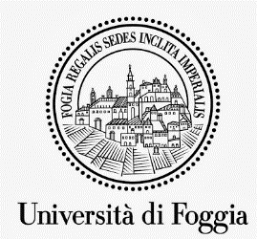
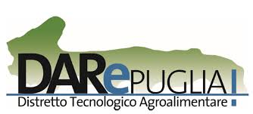
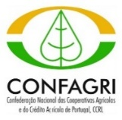
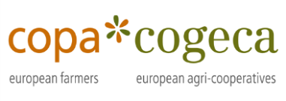
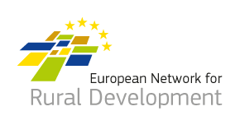
Supporters:
Partners:

