INFORMATION FOR DAVID LAMB

AGENDA

12:00 Registration
12:30 Opening – Introductory remarks by MEPs: Marijana Petir, Paolo De Castro
12:40 Introductory remarks: José Ruiz Espi, DG AGRI
12:50 Presentations
Tajana Radić, Croatian Chamber of Agriculture – uP_running project
dr.sc. Biljana Kulišić, Energy Institute Hrvoje Požar; DSPF Farm Circle: Young farmers as Circles of Circular Economy
prof.dr.sc. Massimo Monteleone, University of Foggia; How we can use more agricultural pruning’s in our countries-Policy recommendations
13:20 Panel discussion Evangelos Koumentakos COPA-COGECA, Jean-Marc Jossart Secretary General AEBIOM, Tina Papasideri INASO-PASEGES
14:00 Closing remarks
Cocktail lunch
Moderator: David Lamb, European Network for Rural Development

SPEAKERS
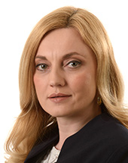
MARIJANA PETIR
Group of the European People's Party (Christian Democrats) Member
Croatia Independent
Political groups
01.07.2014 : Group of the European People's Party (Christian Democrats) - Member
National parties
25.01.2018 : Independent (Croatia)

Member
- 01.07.2014 / 18.01.2017 : Committee on Women's Rights and Gender Equality
- 01.07.2014 / 18.01.2017 : Committee on Agriculture and Rural Development
- 14.07.2014 ... : Delegation to the EU-former Yugoslav Republic of Macedonia Joint Parliamentary Committee
- 19.01.2017 ... : Committee on Women's Rights and Gender Equality
- 19.01.2017 ... : Committee on Agriculture and Rural Development

Substitute
- 01.07.2014 / 18.01.2017 : Committee on the Environment, Public Health and Food Safety
- 14.07.2014 ... : Delegation for relations with Israel
- 14.07.2014 ... : Delegation to the Parliamentary Assembly of the Union for the Mediterranean
- 19.01.2017 ... : Committee on the Environment, Public Health and Food Safety

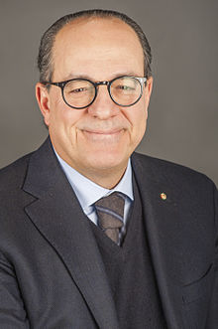
PAOLO DE CASTRO (born 2 February 1958) is an Italian politician, and former Italian Minister of Agriculture, Food and Forestry Policies. In 2009 he was elected to the European Parliament, and currently serves as chair of the parliament's Committee on Agriculture and Rural Development.
He has also served as professor of Agricultural Economics at the Veterinary Medicine University of Bologna. He is married and has two sons.
Early life and career
Born in San Pietro Vernotico, Apulia, as a son of farmers, De Castro grew up on the family’s 36-hectare farm.[1] In 1980 he graduated at Bologna getting the maximum mark in Agricultural Science.

Career
From January 2001 to May 2004, De Castro chaired the "Nomisma" Economics' Studies Institute. He also chaired the Qualivita Foundation and currently runs the International Agricultural Policy Magazine edited by the Informatore Agrario in Verona. He is professor at the Agriculture Academy of Bologna, the Georgofili Agricultural Economics Academy of Florence, the Agriculture Academy of Pesaro and the National Academy of Treja. From 1996 to 1998 he was economic advisor of Prime Minister Romano Prodi and Economic Advisor of the Minister of Agriculture and Forestry Resources, Michele Pinto. Since 1 June to 31 December 2000 he was appointed as special Advisor of the EU Commission's President. From 21 October 1998 to 25 April 2000 he served as Minister of Agriculture and Forestry Policies in both Governments chaired by Massimo D'Alema. On November 2000, President Carlo Azeglio Ciampi awarded him the "Cavaliere di Gran Croce al merito della Repubblica Italiana"merit honour. He is scientific coordinator of the International Center for Advanced Mediterranean Agronomic Studies (CIHEAM) in Paris, and scientific Director of the Genio Rurale Magazine: a magazine on goods evaluation and territory science of Edagricole. He is also member of the Italian Agricultural Economists' Society (SIDEA) and of the European Agricultural Economics Association (EAEA).

Minister of Agriculture, Food and Forestry Policy
Candidate at the Political Elections held from 9 to 10 April 2006 in Apulia in the Olive Tree list, De Castro was elected in the XV Legislature. In May 2006 he was appointed Minister of Agriculture, Food and Forestry Policies in the Government chaired by Romano Prodi.

Member of the European Parliament
De Castro became a Member of the European Parliament following the 2009 European elections. In parliament, he is a member of the Progressive Alliance of Socialists and Democrats group. Since 2009 he has since been serving on the Committee on Agriculture and Rural Development. Between 2009 and 2014, De Castro acted as the committee’s chairman. In this capacity, he led the parliament’s negotiations in 2013 with the Council of the European Union on the Common Agricultural Policy (CAP) budget for 2014-2020.[2] Since 2014, he has been serving as his parliamentary group’s coodinator on the committee.
In addition to his committee assignments, De Castro has been a member of the parliament’s delegation for relations with the United States since 2011. From 2009 until 2011, he was also a member of the delegation for relations with the Palestinian Legislative Council.

INTRODUCTORY REMARKS
JOSE RUIZ-ESPI, EUROPEAN COMMISSION
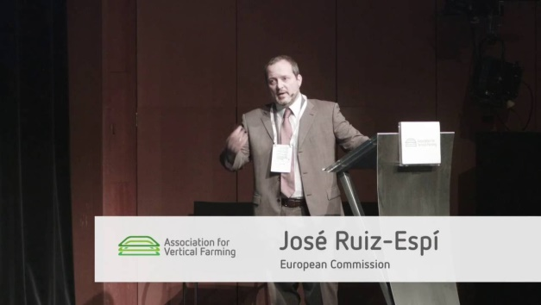

PRESENTATIONS
TAJANA RADIĆ
Executive MBA in Agribusiness
Master in Political Science
Head of the Department for Regional Development
• Coordination and development of the projects financed by the World Bank, Pre-Accession European Union Funds and international partners (preparation of TOR, communication with partners, budget planning, monitoring, evaluation, review and reporting)
• Organization of international exchange for 600 farmers in order to inform them about Common Agricultural Policy after 2013. and Croatian accession in the EU
• Organization of a seminars and international events
• Regular meetings with farm associations to inform them about Common Agricultural Policy
• Regular communication and organization of media events in order to promote Common Agricultural Policy
• Negotiation with national and international partners, State Administration, Government (monitoring of national legal regulations, advocating for the position of farmers in the institutions of the European Union and Republic of Croatia)
• Project executive in the renewable energy projects under HORIZON 2020 (uP_running)

Membership:
• Copa-Cogeca and CDG groups (Rural development, Direct payments, CAP, Livestock)
• National Employment Strategy Committee
• Rural Development Measure 19. Local Action Groups
• National Subgroup on Regional Development Strategy
• National Board Food Waste
• Advisory Group Milk Production
• National Committee Legislation on Unfair Trading Practices
• National Committee Producers Groups
• National Committee Family Farms
• National Committee Advisory Service

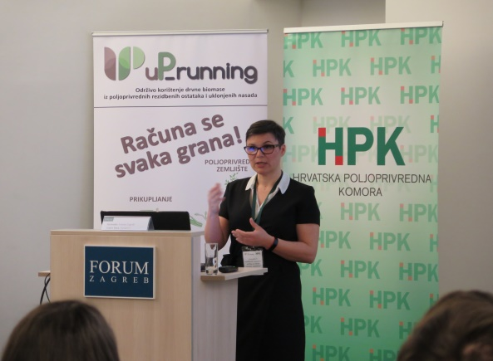
BILJANA KULIŠIĆ has a PhD in agro economics and is specialized in biomass supply from agriculture and forestry streams. Current position is senior biomass researcher at the Department of Renewable Energy Sources, Energy Efficiency and Environmental Protection of Energy Institute Hrvoje Pozar, Croatia. She has been with IEA Bioenergy since 2005, first as a junior assistant at Task 29: Socio-economic drivers of bioenergy projects and, since 2014, National Task Leader for Task 43: Biomass supply for energy markets. In short, her job description is overlapping energy sector with agriculture and forestry but her research focus is on finding new business models for bioenergy projects in order to improve market competitiveness for bioenergy. She was both leading and participating in more than 10 international research/expert projects from EU to FAO and worldwide. She has been participating as an expert in creation of several national legal frameworks (Biofuels market reports, FiT, National plan for renewable energy in transport, Act on SRC…). She is active in raising public awareness on bioenergy by participating in numerous public debates, panels, roundtables ranging from local NGOs and farm associations to the Agriculture Committee to the Croatian Parliament.
Her current engagement is familiarizing Agriculture & Forestry Extension Service with bioenergy concepts on-farm, valorizing lignin chain (COST Action) and creating new business models for competitive bioenergy (biogas, wood processing industry, WWTP, ecosystem services).

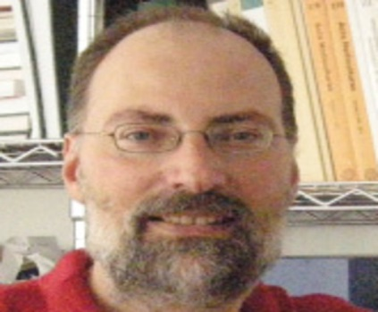
MASSIMO MONTELEONE is professor in Agronomy (crop science) at the University of Foggia (Italy). He is currently teaching "Crop Ecology" (Bachelor degree course) and "Environmental and Territorial Agronomy" (Master degree course) at the Department of Agriculture, Food and Environment of the same University. The unifying concept of “bioeconomy” is particularly useful in portraying his scientific attention. In his research, non-food crops, crop residues, by-products and waste, together with alternative cultivations (such as algae) are considered for industrial and energy applications. The optimization of the whole value chain is targeted to build up a strategy to reconcile bio-based productions with the ecological harmony and the cultural heritage of relevant rural areas and promote rural development. He is currently coordinating the “STAR*AgroEnergy” research group (formerly an EU FP7 project), characterized by a strong interdisciplinary attitude, aiming to work out an integrated approach to both renewable energy generation and industrial bioproducts, according to sustainability criteria. His research interests include crop ecology; environmental analysis; LCA applied to agriculture and agro-industry; agro-ecosystem management; rural land planning and energy planning; biomass, bioenergy and bio-materials; farming management such as soil organic conservation, crop irrigation, soil salinization control.

PANEL DISCUSSION

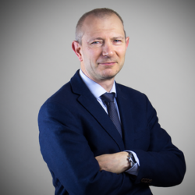
JEAN-MARC JOSSART, Secretary General, AEBIOM
With over 20 years of experience, Jean-Marc Jossart has diversified expertise on bioenergy technologies, energy crops, transport biofuels, biomass production, environmental impacts, policies, economics, and support schemes. As AEBIOM’s Secretary-General, he is responsible for the general management of the organisation including the public representation of positions defended by AEBIOM. Jean-Marc Jossart is agronomist (UCL, 1989, Belgium) starting his career almost directly in the bioenergy sector. He speaks English and French.
QUESTIONS
- What your organization see as the main benefits from agro-residue use and how agro-residues could support growth of rural areas?
- Do you think that policy makers in Brussels realize the potential of agro biomass for the energy submission or it is forgotten topic because nobody brings it up? Do you think that more coordinated efforts between the biomass and the agricultural sectors are needed in order to unlock the potential?
- In your opinion, what are the main legal, administrative or budget limitations to the deployment of agro-residues use-to-energy? More specifically, what should be changed or modified in order to increase the use of agro residues?

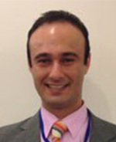
Evangelos KOUMENTAKOS, COPA COGECA
Senior Policy Advisor
- Environmental issues: climate change, air, soil, waste, emissions
QUESTIONS
- What is the position of Copa-Cogeca members on better use of agro-residues?
- What kind of changes your members suggest in a next budget period in order to better use of agro-residues?
- Why do you think use of agro-residues could support development of rural areas?

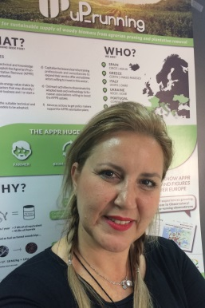
Tina PAPASIDERI, INASO-PASEGES
With studies in Informatics – Programming and Analysis, and college degree in Terminology of Computer Science. Being a representative on committees of Greek ministry of agriculture and rural development. She has long experience in management of critical matters and communication, developing and maintaining contacts with stakeholders mainly in the field of agriculture cooperatives. She has also experience in national and European projects.
QUESTIONS
1. How did the co-operative organizations welcome this new way of energy utilization of agricultural pruning and plantation removal?

2. After the completion of the demo actions, in the context of project implementation, what is the view that has been formed? What measures do they think need to be taken to make such an initiative sustainable?

